Wordpress

Filter Post By Custom Fields

<https://www.advancedcustomfields.com/resources/query-posts-custom-fields/>

<https://www.advancedcustomfields.com/resources/orde-posts-by-custom-fields/>

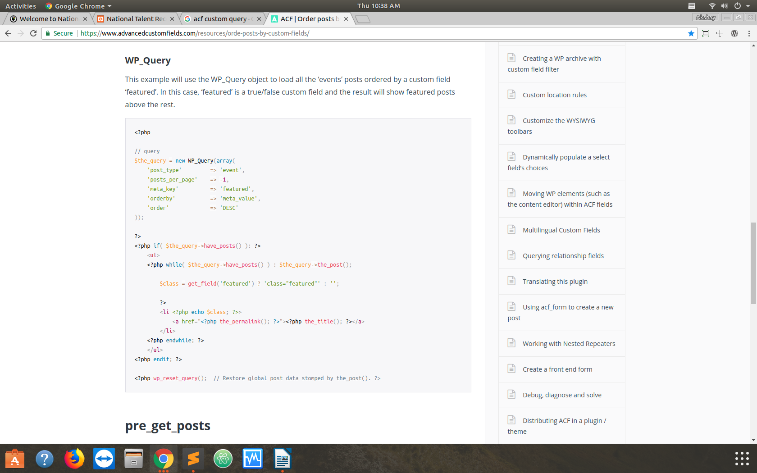

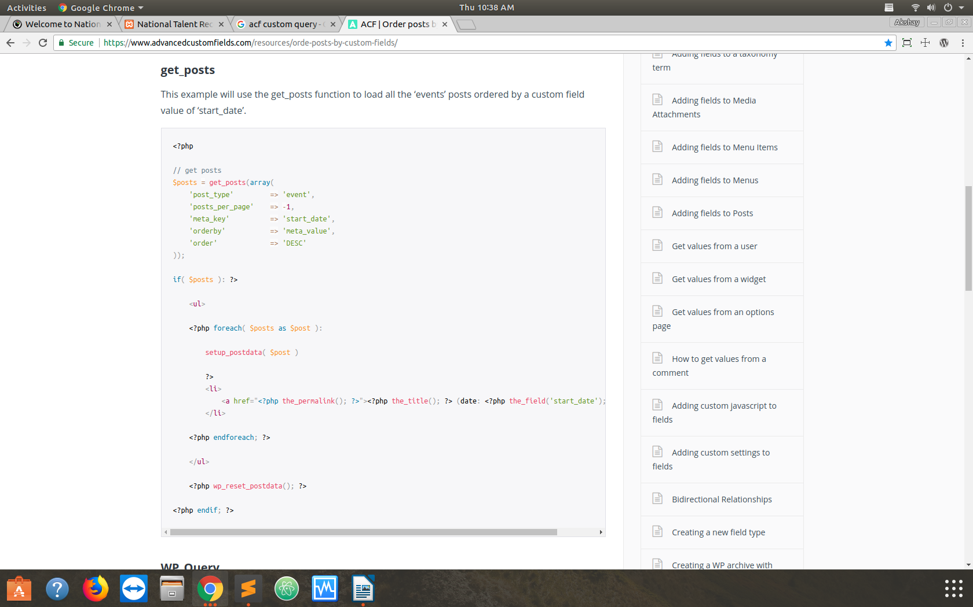

Calling One Page’s Content to another page

